# 2023 Quiz Rally

#### This will be a Standard Rally, where members may qualify for both the 2023 and the 2024 Championships.

**Date**: Saturday, May 6, 2023

**Location:** San Marin High School, Novato, CA

**Fees:** $65 per competitor:

**Extras:** lunch and T-shirt optional (additional fee).

**Registration**: open now and **closes on April 9th**. Fees must be paid at the time of registration. Fees are not refundable. Preferred payment method a club check payable to Sierra Pacific Region.

Rally Registration is not complete until all printed forms and payments are received by the Rally Secretary

**Mail completed printed entries and Club checks** to Becky Williams at 1011 Emerald Ln, Fortuna, CA 95540

**Rally Organizer:** Becky Williams - Treasurer, [sierrapacifictreasurer@gmail.com](mailto:sierrapacifictreasurer@gmail.com), (707) 362-5163

**Volunteers:** Quiz Rally runs on volunteers! Each team must have a chaperone present and at least one adult to volunteer.

**Rules:** [USPC Rules and Handbook for Quiz](https://www.ponyclub.org/Members/Rulebooks.aspx) (2023)

**Teams:** Teams will consist of 3 or 4 members within the following divisions:

* ***Novice D:*** D1/UR to D3 HM, 11 and under as of 01/01/2023
* ***Novice C:*** C1 HM & C2 HM 11 and under as of 01/01/2023
* **Junior D:** D1/D2/D3 HM; 12-17 years of age as of 01/01/23
* **Senior D:** D1/D2**/**D3HM; 18+ years of age as of 01/01/23
* ***Junior C and up*** C1 HM and up; 12-17 years of age as of 01/01/2023
* ***Senior C and up:*** C1 HM and up; 18+ years of age as of 01/01/2023

**NOTE:** Quiz competitor MUST BE AT LEAST 10 YEARS OF AGE as of JANUARY 1, of the championships year and rated at least D-2 HM. Upon completion of the quiz rally competitors who meet age and rating criteria will be marked eligible and receive an invite to sign up for 2023 or 2024 USPC Championships when entries open.

***Competitors that wish to qualify for championships and expect to be the minimum age and certification by then, but are not currently, may “compete up”. For example a D1 member who wishes to qualify for championships and plans to take their D2 before the championships, must sign up and compete as a D2 at this Quiz rally in order to qualify. Members wishing to attend championships should sign up for the division that matches the age they will be on Jan.1 of the year of the Championships they wish to attend.***

**Rally Schedule:**  (may change depending on the number of entries)  
8:00 a.m. Registration opens **Chaperones must pick up packets!  
8:00 - 9:30 Breakfast (available for purchase)**  
8:30 Judges and Volunteers' Briefing  
8:45 Competitors' Briefing  
9:00 Competition begins  
4:00 p.m. Rally concludes at approximately  
5:00 Ribbon/Award Ceremony

**Breakfast, snacks, baked goods, and drinks will be available for purchase throughout the day!

**Required Attire:** Armbands with a USPC Medical Card or Medical Bracelet are required for competition. Barn safe boots are required for the Barn Phase of the competition. Remember to wear your Pony Club Pin!

**LUNCH:** Pre-orders for lunch will be taken, with choices of Sandwich, fruit, chips, and a bottle of water. Lunch is $10 for competitors, extra lunches can be ordered for $10. Competitors and coaches are welcome to bring their own food.

**Note to DCs & CAs or Club Rally Coordinator:**

Please promote the rally to your members. Make sure they understand the criteria for qualifying for championships.

* Determine the team make-up (name of the team, team members, captain). Make sure each participant is aware of it. If you do not have a complete team, we will help place your members in a team with other clubs.
* Help your members prepare for the rally.
* Each team needs to have a chaperone and volunteer!

**REGISTRATION INFORMATION:**

**Team registration packets are due on April 9th, 2023**.

For each team,

**Mail the following to the Rally Secretary:**

1. Team Designation Form – **one per team** - even if it is not a full team, we need this form completed for scramble registrations too
2. Quiz Individual Registration Forms for all competitors, one per person
3. Chaperone Rules/Duties Form – one per team or partial team/club - will be found at <https://www.ponyclub.org/ContentDocs/Champs/ChaperoneDutiesForm.pdf>
4. T-Shirt and Lunch Forms
5. Club check made payable to Sierra Pacific Region PC covering all fees due for all competitors-one per club. If your club’s payment needs to be made with a different method, contact Becky Williams. [sierrapacifictreasurer@gmail.com](mailto:sierrapacifictreasurer@gmail.com), or call/text 707-362-5163

If your club cannot form a complete team, please indicate this on the Team Designation Form, and the organizers will put your members with competitors from other clubs to form scramble teams. Please indicate if any participant is comfortable with the role of team Captain on a scramble team.

**Information for individual competitors**:

Registrations for the rally should be submitted by the DC or club rally coordinator in teams. Please confirm with your club DC when individual forms and payments are due to be submitted to them. For each competitor, please complete and return the following to your DC or rally coordinator by their designated due date (NOTE: This will be before April 9th)

1) Quiz Individual Registration Form – one per person

2) Your check or payment is made payable to your own Pony Club so that your club can write a single check for the team to register for the rally. – one per person

3) shirt and food orders if you are getting either

## 

## Championships Divisions-Minimum Age and Certifications and Eligibility Process

### USPC Quiz Rulebook 2023 - Articles 29, 30, and 31

To be eligible for Championships, competitors must meet the age parameters and minimum certifications for the offered Championships divisions. Age is as of Jan. 1 of the (Championship) competition year, and there are no age and no certification exceptions to the below requirements. See Article 5 for more details on age and certification minimums.  
Divisions:

* ***Modified Novice D:***  D2 & D3 HM, 10-11 years of age
* ***Modified Novice C:*** C1 HM & C2 HM, 10-11 years of age
* ***Modified Junior D:*** D2 & D3 HM, 12-17 years of age
* ***Modified Senior D:***  D2 & D3 HM, 18+ years of age
* **Junior D:** D3 HM, 12-17 years of age
* **Senior D:** D3 HM, 18+ years of age as of 01/01/23
* ***Junior C and up:*** C1 HM and up, 12-17 years of age
* ***Senior C and up***: C1 HM and up,18+ years of age

Each individual Pony Club member who desires to compete at Championships must compete in a regional rally and be judged at the minimum Horse Management certification and same competition level in which they intend to compete at Championships. This constitutes the “individual eligibility” of the competitor

Members wanting to become eligible for Championships must meet the division criteria below.

Modified Novice D, Modified Novice C, Modified Junior D, Modified Senior D: Complete a standard Quiz rally (or modified of no standard available)

Junior D, Senior D, Junior C & up, Senior C & up: complete a standard Quiz rally

Certified H-B/H-A members wishing to compete at Championships do not have to participate at a regional Quiz rally but must have permission of their RS.

T-shirt information: **Cost $20**

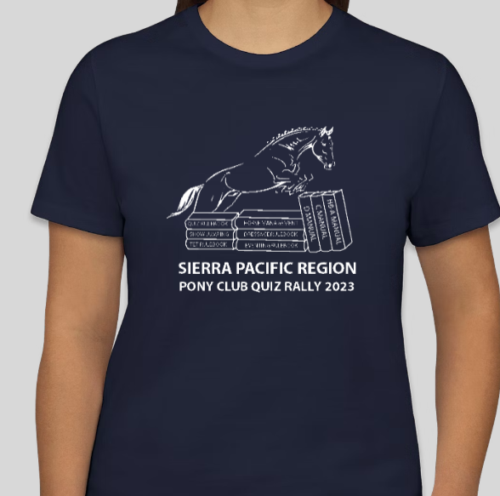

**White lettering on Navy** – below is the sketch of the artwork

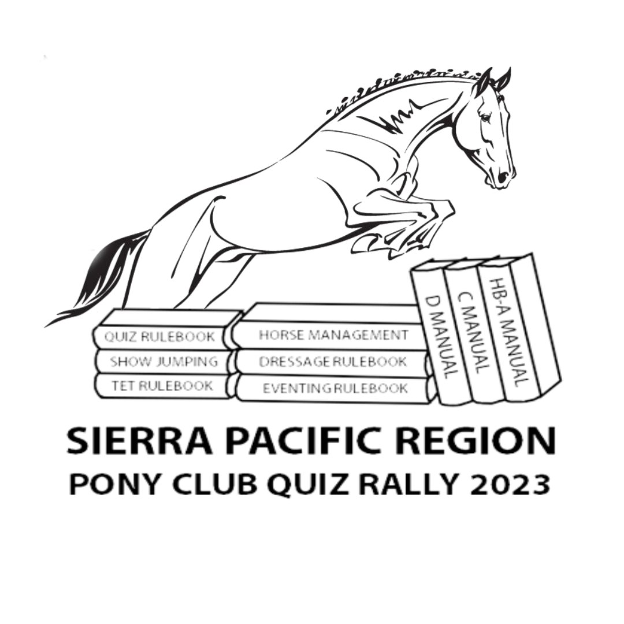

Size charts:

Youth:

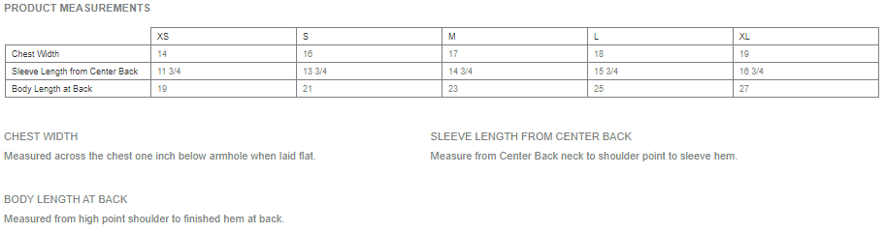

Ladies:

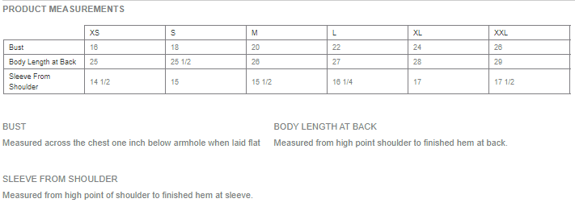

Unisex:

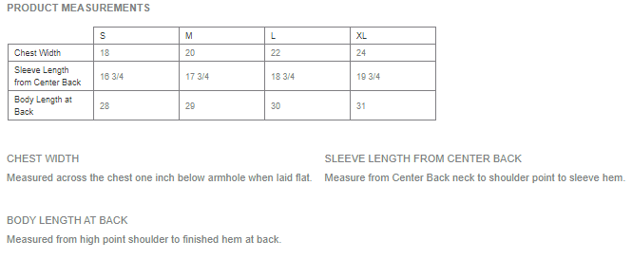

**2023 Quiz Rally Entry**

Individual Registration Form

(Print One per Competitor - single sided)

Name: __________________________________________________________________

Pony Club: ______________________________________________________________

Address: ________________________________________________________________

Email: _____________________________________Telephone: ____________________

Current HM Certification: ___________________

(If over 18, please just indicate “Adult” below)

USPC Participation Age: (age on 1/1/2023): ___________Date of Birth: ____

**Parent/Emergency Contact:**

Name: __________________________________________________________________

Relationship: _____________________________________________________________

Email: _____________________________________Cell: _________________________

**T-shirt: $20.00 optional (order form below)**

**Lunch for competitors & extra Lunches -**  $10.00 each optional **(order form below)**

All lunches include Sandwich, fruit, chips, and a bottle of water

**Entry Fees**

Team Member $65.00

Entry Fee: $_______________

Lunch $10 X______Total Fee: $_______________

T-shirt $20 X______Total Fee: $_______________

Total Individual Rally Fee: $_____________

**(Print this page single sided – we need to provide this information to the suppliers)**

**2022 Quiz Rally - T-Shirt Order Form**

**Competitor Name: _____________________________________________**

**Pony Club/ Team : _____________________________________________**

Circle One:

Youth: XS S M L XL

Ladies: XS S M L XL XXL

Adult: S M L XL

**If additional shirt, please indicate below:**

**Style:____________ Size: _________**

**Style:____________ Size: _________**

**Number of shirt total for this entry: ___________**

**2022 Quiz Rally - Lunch Order Form**

**Competitor Name: ___________________**

**Pony Club/ Team:______________________**

**Lunch for competitors $10.00:**

Circle Choice :

Sandwich: Ham Turkey Veggie ( Green Goddess)

Bread: White Whole Wheat Gluten-Free

Cheese: American Cheddar Swiss None

Condiments: Lettuce Tomato Mayo Yellow Mustard Vinegar/Oil Salt/Pepper

All lunches include fruit, chips, and a bottle of water

**(Print this page single sided – we need to provide this information to the suppliers, feel free to cut to half-sheets if you can share the form with more than one family)**

**Extra Lunches $10.00 each**

**Name: ____________________________________**

**Club: __________________**

Circle Choice:

Sandwich: Ham Turkey Veggie ( Green Goddess)

Bread: White Whole Wheat Gluten-Free

Cheese: American Cheddar Swiss

Condiments: Lettuce Tomato Mayo Yellow Mustard Vinegar/Oil Salt/Pepper

All lunches include fruit, chips, and a bottle of water

**Extra Lunches $10.00 each**

**Name: ____________________________________**

**Club: __________________**

Circle Choice:

Sandwich: Ham Turkey Veggie ( Green Goddess)

Bread: White Whole Wheat Gluten-Free

Cheese: American Cheddar Swiss

Condiments: Lettuce Tomato Mayo Yellow Mustard Vinegar/Oil Salt/Pepper

All lunches include fruit, chips, and a bottle of water

**2023 Quiz Rally**

Team Registration Form

**( Rally Coordinator - Print One Per *Team* - single sided)**

**Also include Chaperone form (see link above)**

Pony Club: ______________________________________________________________

Entry Submitted by: Phone/email:____________________

Team Captain:____________________________________________________________

Competitor 2:____________________________________________________________

Competitor 3 :____________________________________________________________

Competitor 4 :____________________________________________________________

DC Name: ______ Email: _________

**Team Chaperone:**

Name: __________________________________________________________________

Email: ______________________________________ Cell: _______________________

**Adult Volunteer:**

We can’t run this rally without volunteers, so please send at least one volunteer per team. It will be greatly appreciated! Thanks so much!

Name: __________________________________________________________________

Email: ______________________________________ Cell: _______________________

Name: __________________________________________________________________

Email: ______________________________________ Cell: _______________________

Totals for individuals (optional):

Name:________________________

Name:________________

Name:________________

Name:________________

Total from other team forms:____________

**(Required)** Total for Club Check:____________